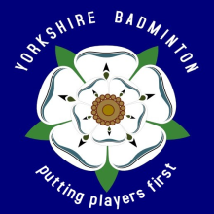 |  | 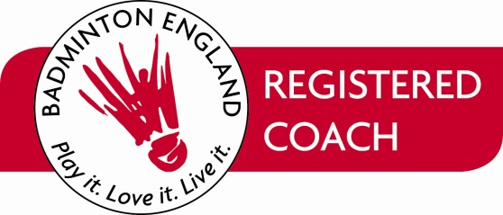
BADMINTON COACHING in YORKSHIRE
JUNIORS
For Junior players the ideal pathway is to join a Junior Club.
YBA recommends that the Club you join should be a Badminton England Premier Club.

To find your nearest Junior Club please follow the following links.

http://www.playbadminton.co.uk/
In the “I want to…” drop down box select PLAY – FIND a CLUB
In the “Where:” box put in your POSTCODE or TOWN
Leave the Keyword Box as it is
Click on SEARCH
A list of Clubs will then appear within a 10 mile radius.
The distance can be altered to a smaller or larger radius.
The Clubs will be listed as Affiliated or Premier.
To find contact details click on the Club name.

Badminton England Premier Clubs are the equivalent to Sport England Clubmark.
Premier Clubs have regular assessments to ensure that they are ‘fit for purpose’.
All the Coaches at Premier Clubs should have Disclosure and Barring Service (DBS) accreditation and be Members of the Badminton England Coaching Register.
A list of Premier Clubs also exists on the Badminton England website. Click on the link.
http://www.badmintonengland.co.uk/text.asp?section=254&sectionTitle=Accredited+Premier+Clubs#.Uj1IqaJwYdU

ONE to ONE COACHING
As well as group coaching (clubs, schools, performance centres etc.), coaches can also provide individual coaching.
The attached list (when populated) will give you the contact details of coaches.
(This list will only contain those coaches who have agreed for their details to be published on this website)

The list of Coaches is currently being updated. In the meantime if you require information please contact Roger Cook 01642 656227 – roger.cook60@ntlworld.com

Please note that Yorkshire Badminton Association does not endorse coaches and you should make sure yourself, that the coach you approach is a current Member of the Badminton England Coaching Register (will have Coaching Register Cards Part A & B) and has the necessary Disclosure and Barring Service (DBS) accreditation.

COACHES
If you wish to have your individual details published on the Yorkshire BA website, please let Roger Cook (YBA Coaching Coordinator) know. I need your permission (under data protection) before I can add you to the list.
I will need your postcode, coaching grade, phone number (only one - home or mobile),
email address and short comment. (e.g. adults only, juniors only, disabled coaching)

